##### EXPERIMENT NO:-01

**Aim: Identify the case study and detail statement of problem. Design an Entity –Relationship(ER)/ Extended Entity-Relationship (EER) Model.**

**Theory:**

## Entity :

Entities are represented by means of rectangles. Rectangles are named with the entity set they represent.



**Attributes**

Attributes are the properties of entities. Attributes are represented by means of ellipses. Every ellipse represents one attribute and is directly connected to its entity (rectangle).

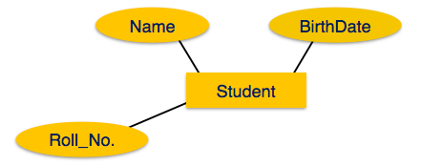

If the attributes are **composite**, they are further divided in a tree like structure. Every node is then connected to its attribute. That is, composite attributes are represented by ellipses that are connected with an ellipse.

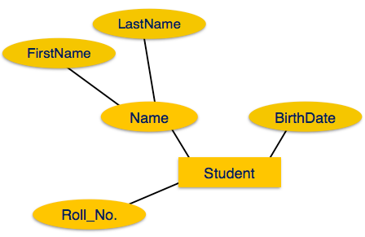

**Multivalued** attributes are depicted by double ellipse.

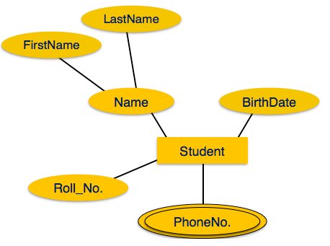

**Derived** attributes are depicted by dashed ellipse.

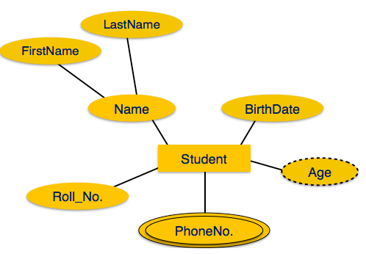

## Relationship

Relationships are represented by diamond-shaped box. Name of the relationship is written inside the diamond-box. All the entities (rectangles) participating in a relationship, are connected to it by a line.

### Binary Relationship and Cardinality

A relationship where two entities are participating is called a **binary relationship**. Cardinality is the number of instance of an entity from a relation that can be associated with the relation.

* **One-to-one** − When only one instance of an entity is associated with the relationship, it is marked as '1:1'. The following image reflects that only one instance of each entity should be associated with the relationship. It depicts one-to-one relationship.

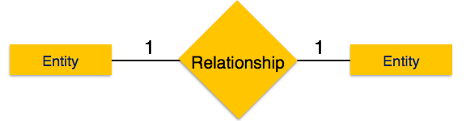

* **One-to-many** − When more than one instance of an entity is associated with a relationship, it is marked as '1:N'. The following image reflects that only one instance of entity on the left and more than one instance of an entity on the right can be associated with the relationship. It depicts one-to-many relationship.

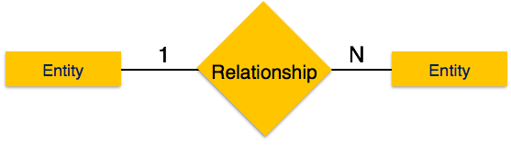

* **Many-to-one** − When more than one instance of entity is associated with the relationship, it is marked as 'N:1'. The following image reflects that more than one instance of an entity on the left and only one instance of an entity on the right can be associated with the relationship. It depicts many-to-one relationship.

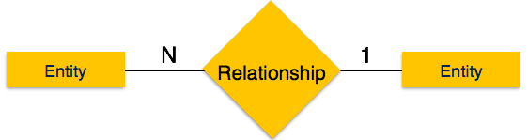

* **Many-to-many** − The following image reflects that more than one instance of an entity on the left and more than one instance of an entity on the right can be associated with the relationship. It depicts many-to-many relationship.

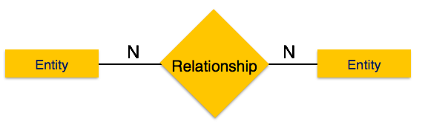

### Participation Constraints

* **Total Participation** − Each entity is involved in the relationship. Total participation is represented by double lines.
* **Partial participation** − Not all entities are involved in the relationship. Partial participation is represented by single lines.

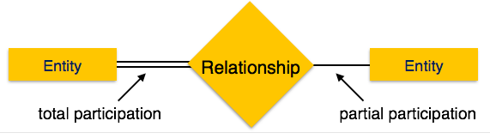

**Case Study:**

Construct an ER Diagram for Blood Donation Camp Management.

ER diagram of Company has the following description:

* set of patients that can receive the blood.
* And also donor who donates blood to patient.
* Each donor donates the blood to only one patient while each patient can accept the blood through many donors.
* Donor has blood bank to store the blood.
* Each patient can receive the blood through many blood bank and also many blood bank can provide blood to many patients.
* patient,donor and blood bank has strong relationship in between them.

**Input & Output:**

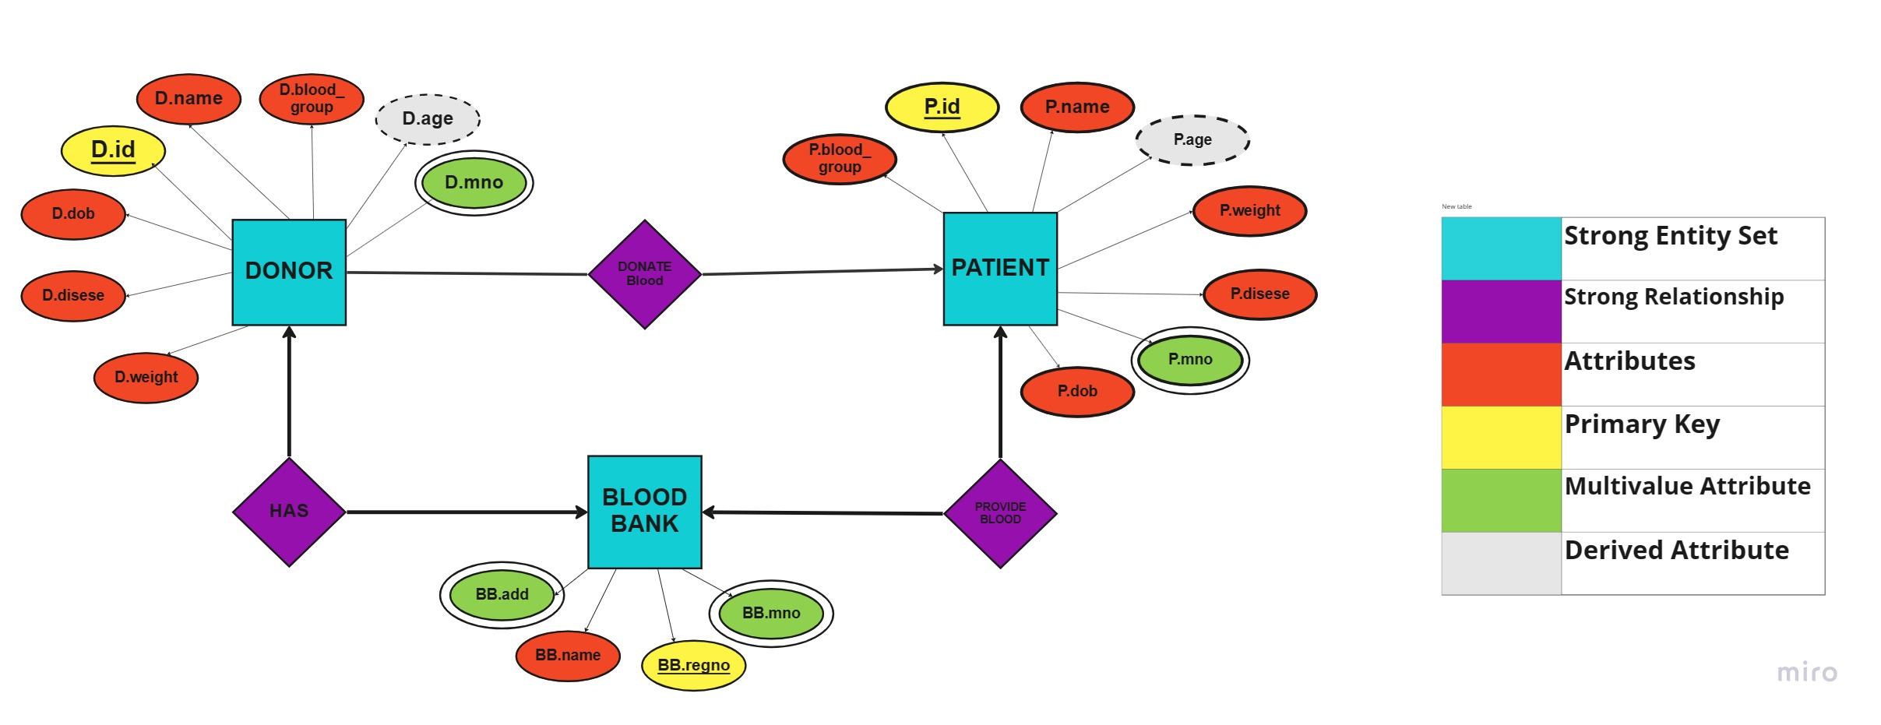

**Conclusion:**

|  |  |  |  |  |  |
| --- | --- | --- | --- | --- | --- |
| **R1** | **R2** | **R3** | **R4** | **Total** | **Sign with Date** |
| **(3)** | **(5)** | **(4)** | **(3)** | **(15)** |  |
|  |  |  |  |  |